Bookstore Assignment

Name: Areeb Abbasi
ID: BB-7648
Course Code: CS222
Instructor: Sir. Amjad Jumani
Project Repository:
Home Page:


Add Book:
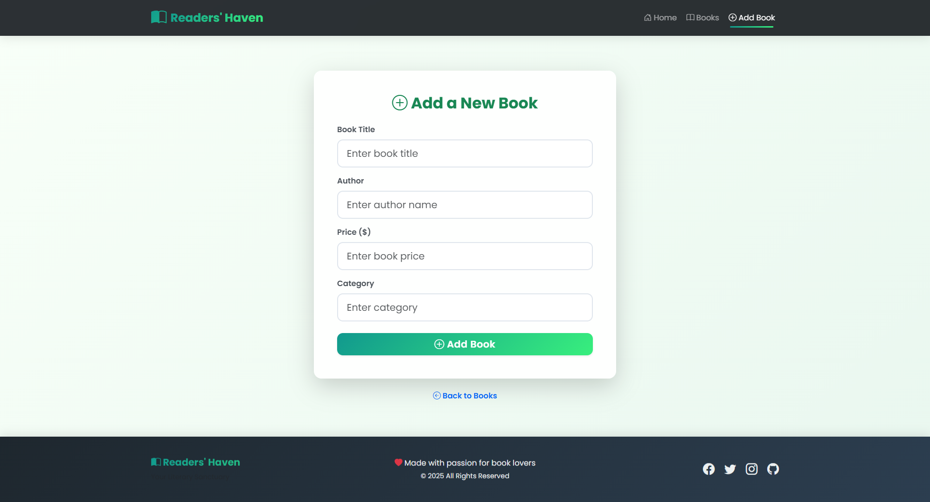

View Books:
